# Exploring the Consumer Functional Interface in Java 8

## Introduction

In this tutorial, we will **code and explore** the **Consumer Functional Interface** introduced in **Java 8**. All new functional interfaces introduced in Java 8 are available in the \*\***java.util.function**\*\* package.

## Exploring the Consumer Functional Interface

1. Open **IntelliJ IDEA** and press **Shift** twice to open the **Search Everywhere** window.

2. Search for **Consumer Interface**.

3. The **Consumer interface** has an **'I' icon**, indicating that it is an **interface**.

4. The **Consumer interface** is annotated with **@FunctionalInterface**, which means it contains exactly one abstract method.

## Methods in Consumer Interface

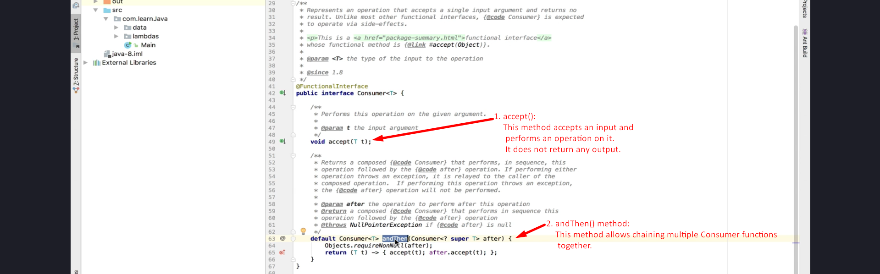  
- We will explore more about this method in upcoming tutorials.

## Exploring the java.util.function Package

1. Click on the **Consumer interface icon** in IntelliJ.

2. This takes us to the **source code**, which is part of the **rt.jar** file.

3. The **java.util.function** package contains several functional interfaces:

- **BiConsumer**

- **BiPredicate**

- **BiFunction**

- **UnaryOperator**

- **BinaryOperator**

4. All these interfaces were introduced in **Java 8** and are categorized as **Functional Interfaces**.

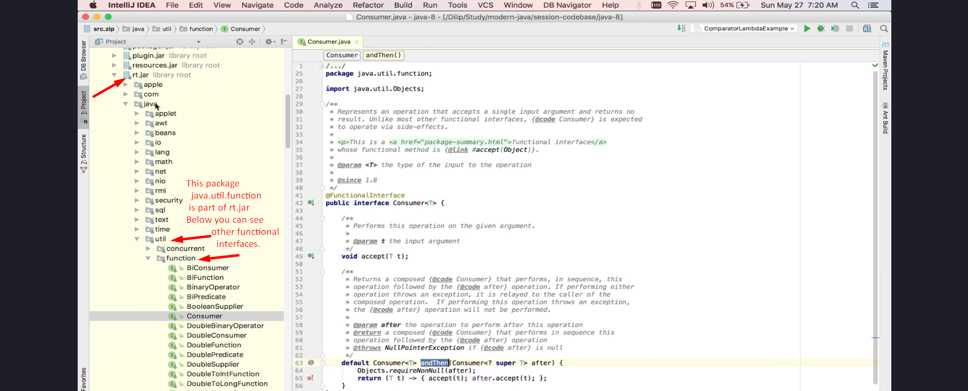

## Implementing the Consumer Functional Interface

1. Create a new package named **functionalinterfaces**.

2. Create a class named **ConsumerExample**.

3. Make the class executable by adding the **public static void main()** method.

### **Code Implementation:**

import java.util.function.Consumer;  
  
public class ConsumerExample {  
 public static void main(String[] args) {  
 // Creating Consumer using Lambda Expression  
 Consumer<String> c1 = (s) -> System.out.println(s.toUpperCase());  
  
 // Passing input using accept() method  
 c1.accept("Java8");  
 }  
}

## Understanding the Code

1. **Consumer<String> c1** → Defines a **Consumer functional interface** that accepts a **String input**.

2. **(s) -> System.out.println(s.toUpperCase())** → The lambda function converts input to **uppercase** and prints it.

3. **c1.accept("Java8")** → Calls the `accept()` method and passes the string **Java8**.

4. **Expected Output:** `JAVA8`

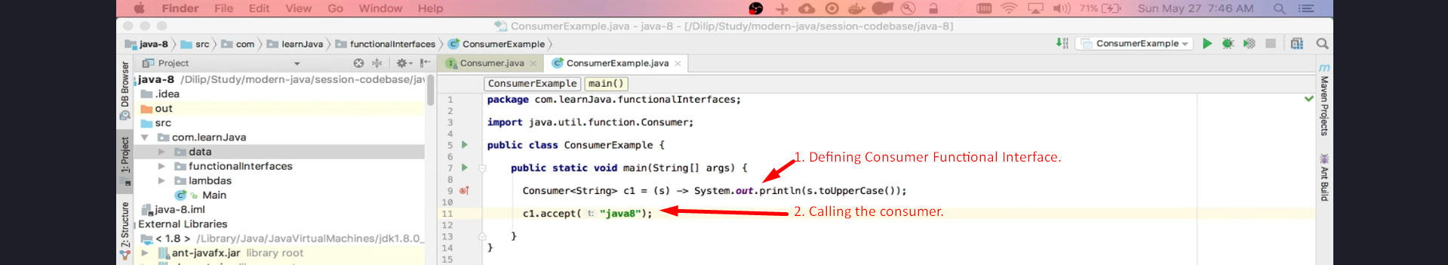  
**Output**:  


## Real-World Use Cases

In upcoming tutorials, we will explore **real-world examples** of the **Consumer Functional Interface**, demonstrating its practical applications.

## Conclusion

- The **Consumer Functional Interface** accepts an input and **performs an operation without returning a result**.

- It is part of the **java.util.function** package introduced in **Java 8**.

- We explored its key methods (`accept()` and `andThen()`).

- Upcoming tutorials will **demonstrate real-world examples** and additional functional interfaces.

### **End of Tutorial**

Thank you for watching!